The general section solver “slices” a section for the fiber-based strain compatibility analysis. It uses the WBFL::Geometry::Shape::CreateClippedShape function passing it a rectangle object. The sides of the clipping rectangle must be aligned with the globally X-Y coordinate system.

The section must be discretized into slices that are parallel to the neutral axis. The CreateClippedShape method can’t clipped with a rotated rectangle, so instead, the section is rotated in the opposite direction of the neutral axis rotation before the clipping occurs.

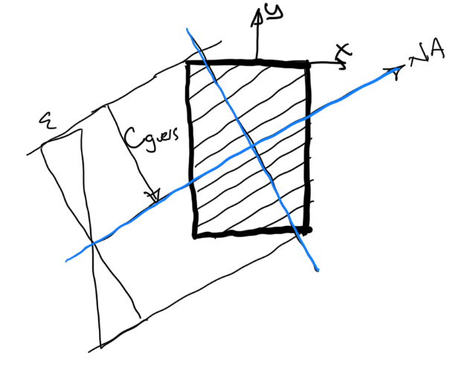

The sketch above shows how we would like to clip the shape but can’t.

The sketch below shows that clipping is accomplished by rotating the shape so the neutral axis is parallel to the global X axis.

